**Assignment 1.1**

**Importing Acadgild VM in to Oracle virtual box:**

**Oracle VM Virtual Box Setup:**

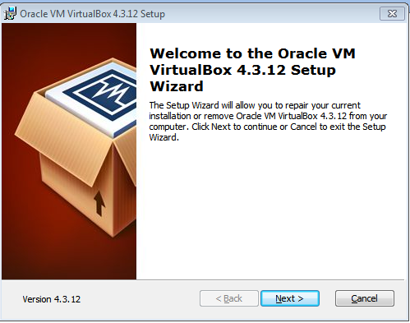

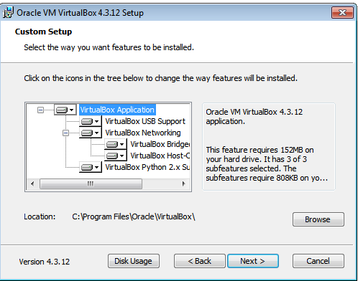

Installing Oracle VM:

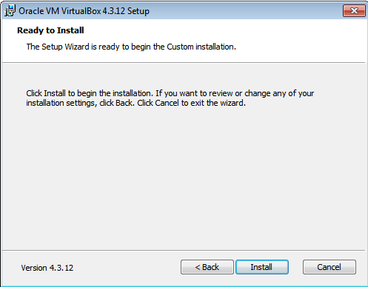

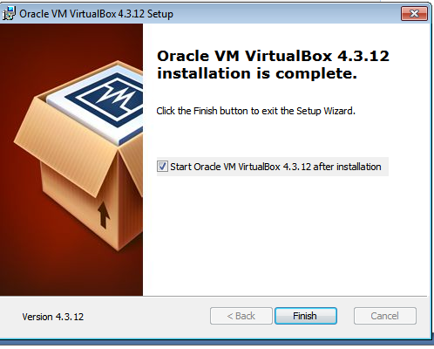

**Importing Acadgild VM:**

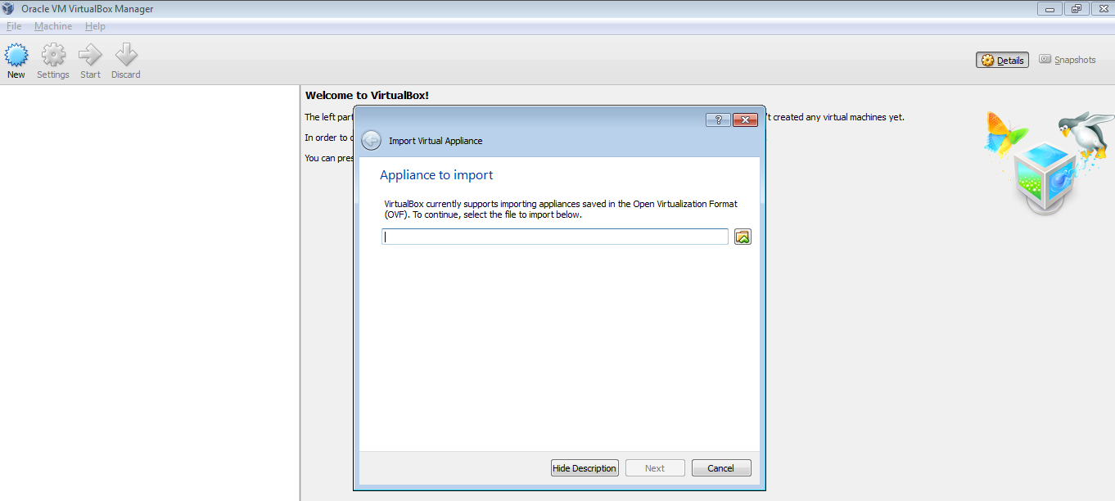

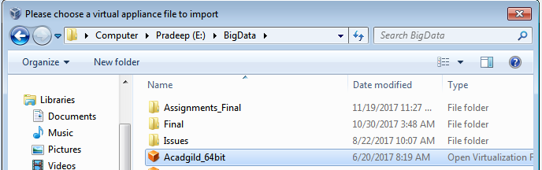

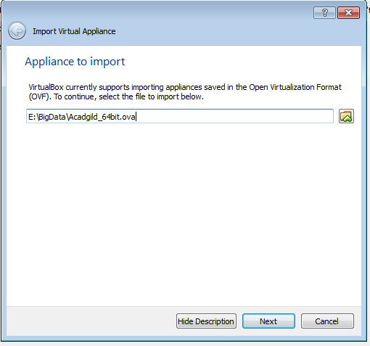

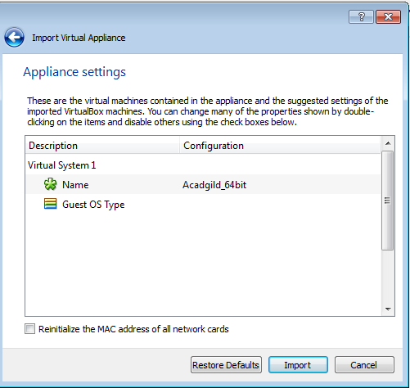

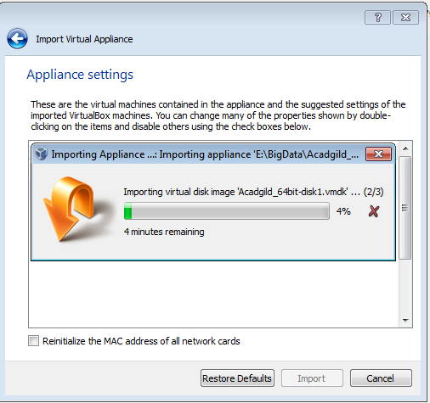

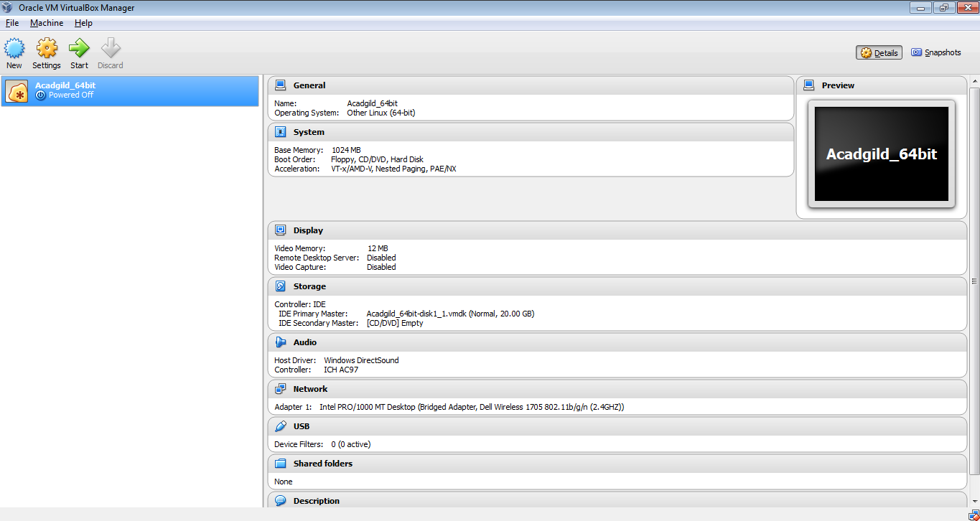

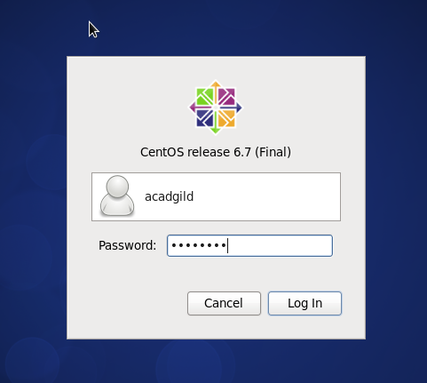

Open the terminal inside Acadgild VM and type commands in terminal:

Typing command **JPS** in terminal to check the list of daemons

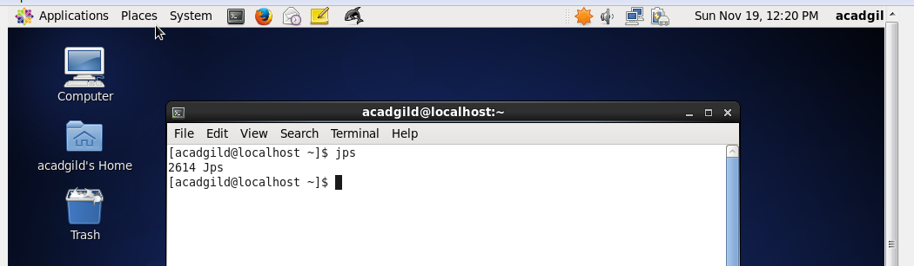

Starting the **ssh server**:

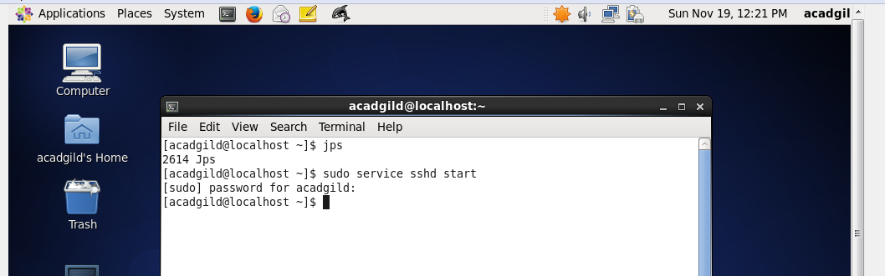

Starting all the daemons:

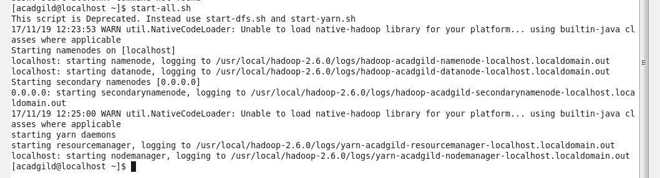

Now again type command **JPS** to check list of daemons:

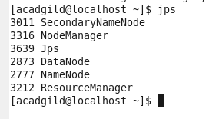

**Starting history server:**

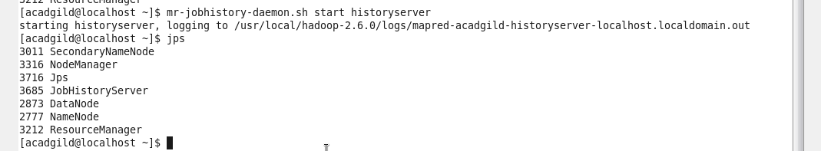

Starting **Pig** in hdfs mode:

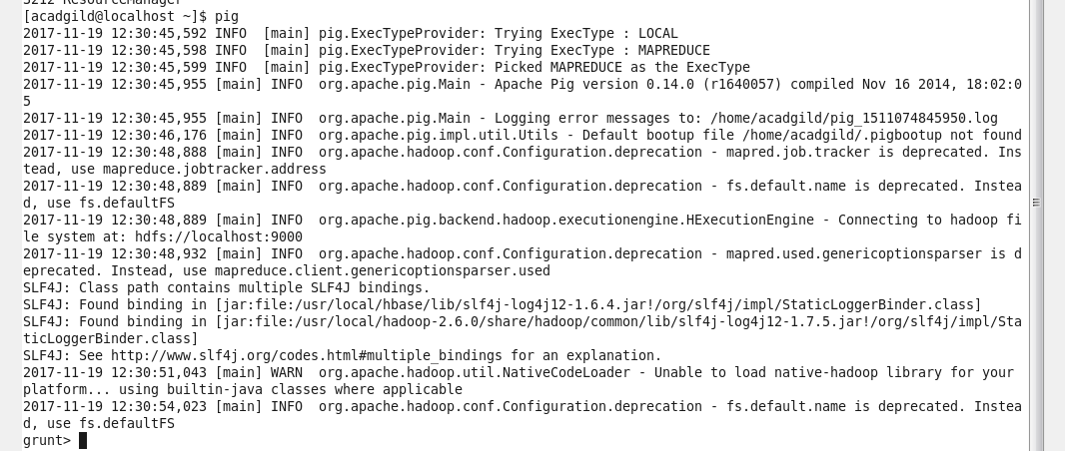

To start **hive** first start mysql service and then type command hive:

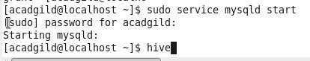

Starting **hive**:

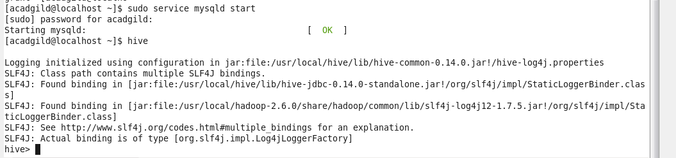

Starting **hbase**:

